CERTIFICATE RENEWAL FOR DB
CERTIFICATE GENERATION
Step 1: switch user to db then cd to host id and sec file.
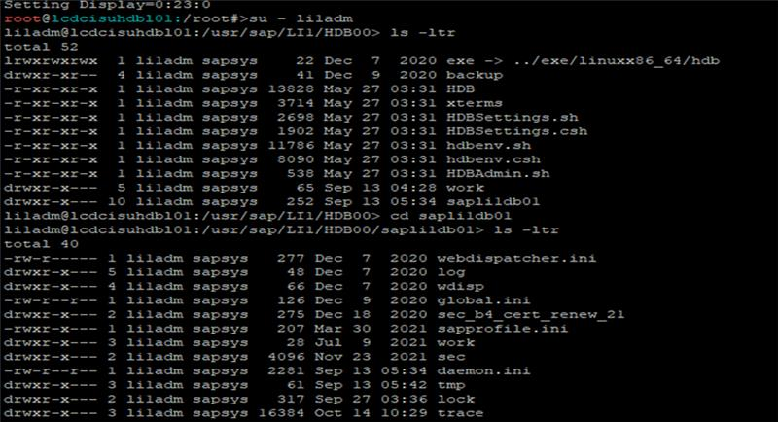
STEP 2: Take backup of sec file 🡪 cp -rp sec sec_backup (cp -rp resourcefile newfile)
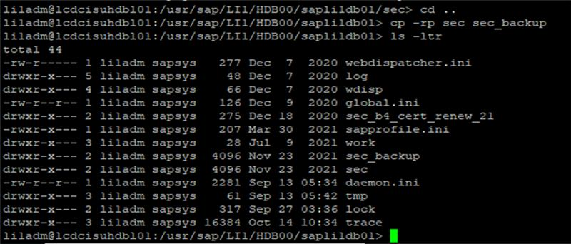

STEP 3: Rename older file of .req and sapssls.pse
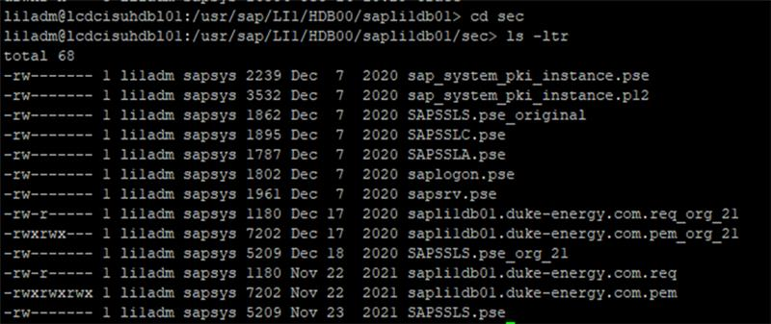
Command 🡪 mv orginal-file-name new-file-name
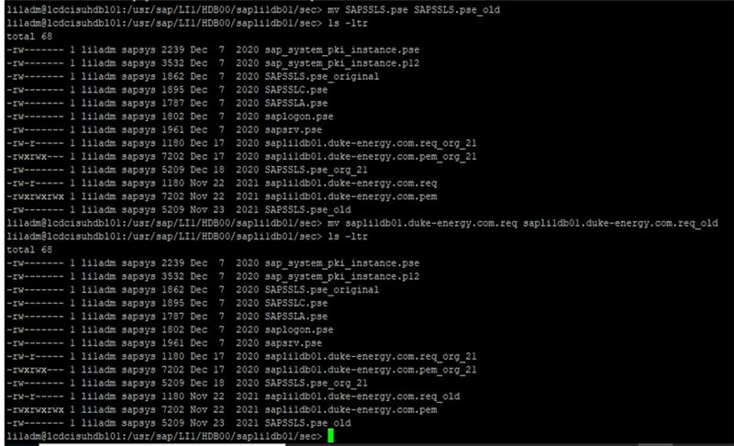

STEP 4: Create new cert file.
- Command for validity checking: sapgenpse get_my_name -p SAPSSLS.pse (sapgenpse get_my_name -p filename)
- Command for creating new cert detail file: sapgenpse get_pse -p SAPSSLS.pse -r sapqm1hdb.duke-energy.com.req -k GN-dNSName:sapqm1hdb.duke-energy.com "CN=sapqm1hdb.duke-energy.com, OU=Customer Connect Technical Services, O=Duke Energy Carolinas LLC, L=Charlotte, SP=North Carolina, C=US"

New files are created to check that file give more along with file name. Then copy details and check in cert check link.
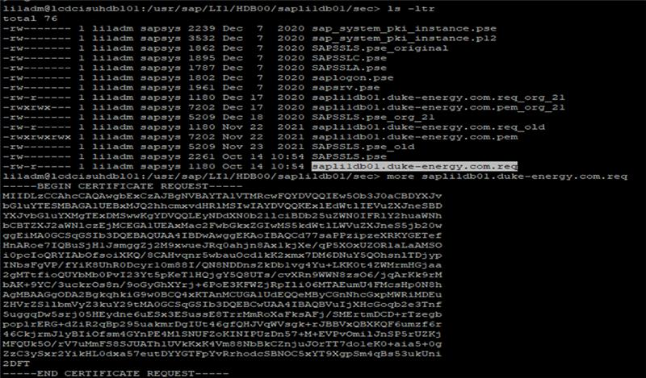
- Run the command cp -rp lcdchyhdbl01.duke-energy.com.req(filename) /sapcd/Keerthana/cert to copy the file in file explorer.

CERTIFICATE IMPLEMENTATION
- Su – sid
- cd sapli1db01(hostname)\sec
- rename pem file
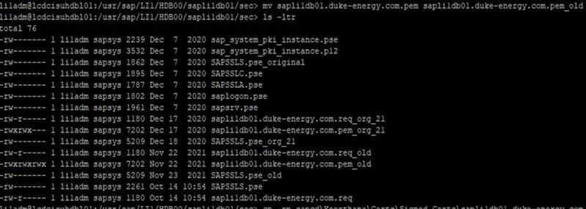
- copy the pem file from file explorer.(with dot at the end of command)
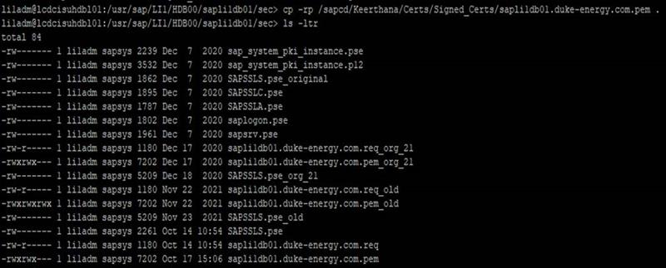

- run the import command
- sapgenpse import_own_cert -v -p SAPSSLS.pse -c sapli1db01.duke-energy.com.pem -- (if it is PH1 this name is as hostname for sapssls.pse)
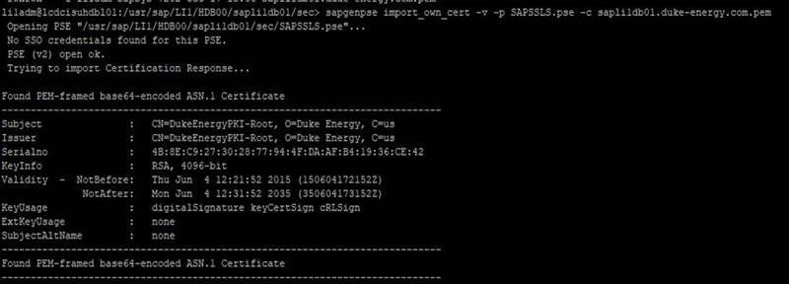
- For checking 2 commands:
- sapgenpse get_my_name -p SAPSSLS.pse
- sapgenpse maintain_pk -p SAPSSLS.pse -t show

- Restart the DB.
- Go to studio 🡪 login into particular sys 🡪 landscape 🡪webdispatcher(stop) 🡪refresh
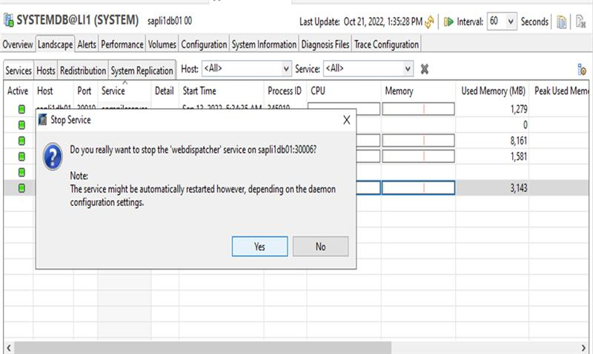
- After restart ,we can check validity thru link https://sapli1db01.duke-energy.com:4300

